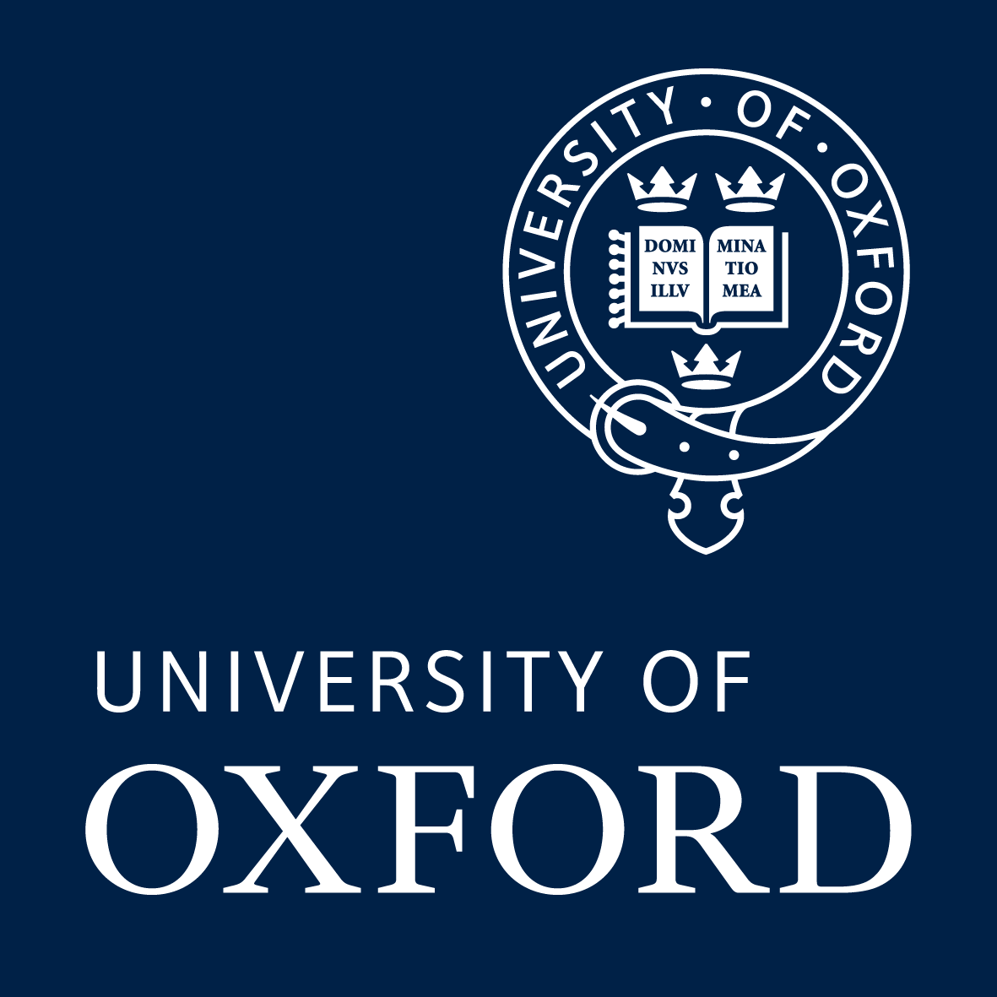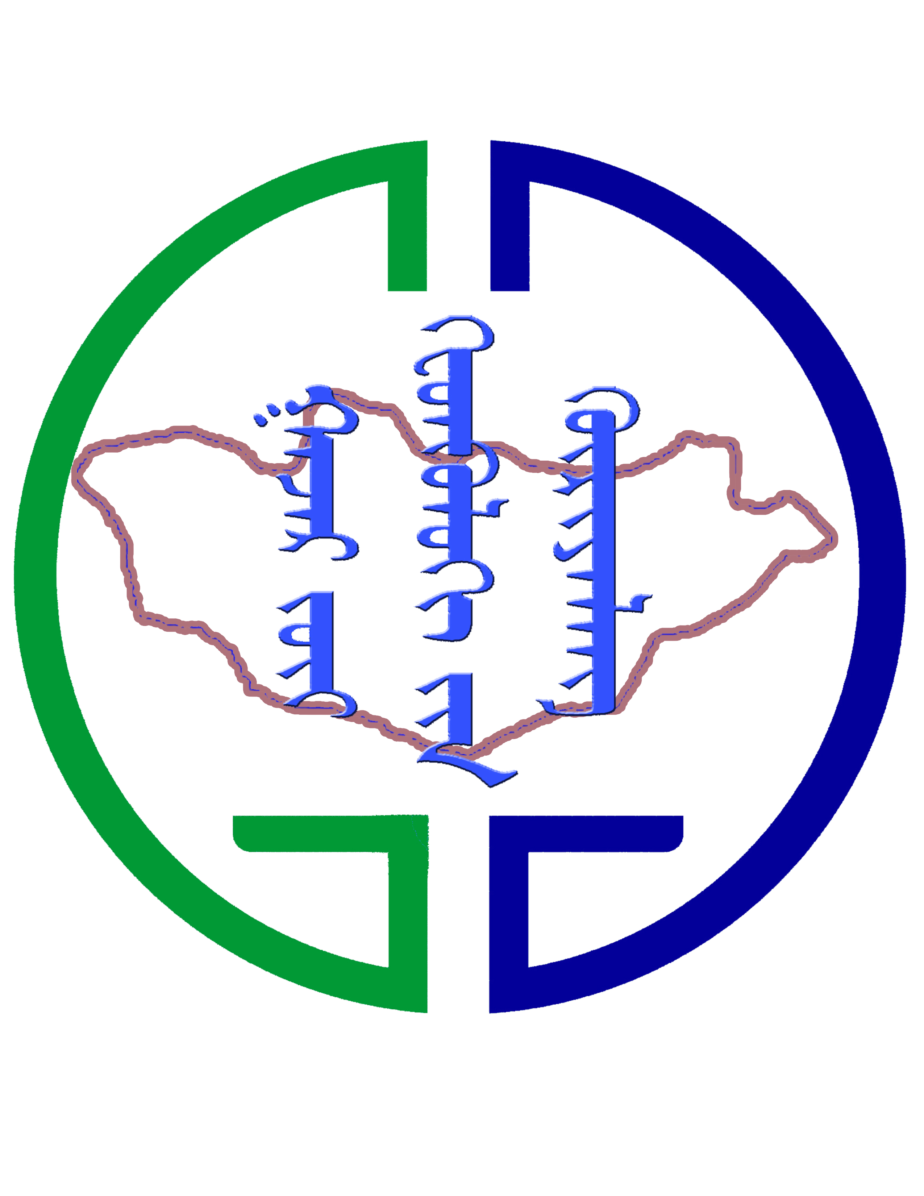

**Oxford University** and the **Institute of Geography & Geoecology, MAS**

are hosting a

**Writing Workshop for Early Career Researchers**

June 27 - June 30, 2016; Mongol Els, Mongolia - expenses paid

**‘Pastoralism, herding & rural livelihood dynamics’**

We welcome abstracts for an expense-paid writing workshop. The goal is for young researchers and PhD students to strengthen and develop English academic writing skills for potential journal articles for ***Nomadic Peoples***. Research papers should have a focus on contemporary pastoralism. All related fields are welcome, including geography, anthropology, development, governance, sociology, etc. The workshop, led by three Oxford University academics and Mongolian scholars, will be in English so fluency in written and spoken English is essential. 15 places are available.

To participate please send an abstract for a potential paper you want to work on, a 1 page CV/resume and a paragraph explaining why you want to attend. If available, a 1 page bullet-point outline of the proposed article would be helpful. Participants will receive a Certificate of Completion.

The workshop will be at Mongol Els. All workshop expenses will be covered, including food, bus and ger accommodation for the 4 day, 3 night programme.

Applications due February 25, 2016. Please email or hand-deliver your material to:

Troy Sternberg – [troy.sternberg@geog.ox.ac.uk](mailto:troy.sternberg@geog.ox.ac.uk)

Ariell Ahearn - [ahearn.ariell@gmail.com](mailto:ahearn.ariell@gmail.com)

Batbuyan Batjav - [b.batbuyan@geo-eco.mn](mailto:b.batbuyan@geo-eco.mn)

Tungalag Ulambayar - [igg.science.secretary@gmail.com](mailto:igg.science.secretary@gmail.com)